- Create a comparison table listing the main differences between DDR3, DDR4, and DDR5 RAM, including speed, voltage, and typical use cases.

Feature | DDR3 | DDR4 | DDR5
Release Year | 2007 | 2014 | 2020
Typical Speed | 800–2133 MT/s | 1600–3200 MT/s (higher with overclocking) | 4800–8800+ MT/s (depending on module)
Operating Voltage | 1.5 V (1.35 V for DDR3L) | 1.2 V | 1.1 V
Bandwidth | Lower | Higher than DDR3 | Highest of the three
Power Efficiency | Lowest | Better than DDR3 | Best power efficiency
Maximum Typical Capacity per Module | Up to 16 GB | Up to 64 GB (consumer modules) | 32–128 GB or more (depending on module type)
Performance | Suitable for older systems and basic computing | Good for gaming, productivity, and general-purpose PCs | Excellent for gaming, content creation, AI workloads, and demanding multitasking
Compatibility | Requires a DDR3-compatible motherboard | Requires a DDR4-compatible motherboard | Requires a DDR5-compatible motherboard
Typical Use Cases | Older desktop and laptop computers, office work, web browsing | Modern desktops, gaming PCs, business computers, everyday multitasking | High-end gaming PCs, professional workstations, video editing, 3D rendering, and future-ready systems

- Open your laptop or desktop (with power disconnected), locate the RAM slots, and take a clear photo of the installed RAM module. Reinstall the RAM module and verify that your system boots up successfully.<br><br><em><strong>Hint:</strong> Refer to your device manual or a trusted YouTube guide if unsure about RAM removal and installation steps.</em>
I can't physically open or handle your computer, or take photos. If you want to complete this task yourself, here's a safe procedure:
- Shut down your computer completely.
- Disconnect the power adapter and any peripherals.
  - For a desktop, switch off the power supply and unplug the power cable.
  - If your laptop has a removable battery, remove it as well.
- Press and hold the power button for about 10 seconds to discharge any remaining power.
- Open the case or service panel according to your device's manual.
- Locate the RAM module(s). They are long, narrow circuit boards installed in memory slots with retaining clips on each side.
- Before touching the RAM, ground yourself by touching an unpainted metal part of the chassis or using an anti-static wrist strap. 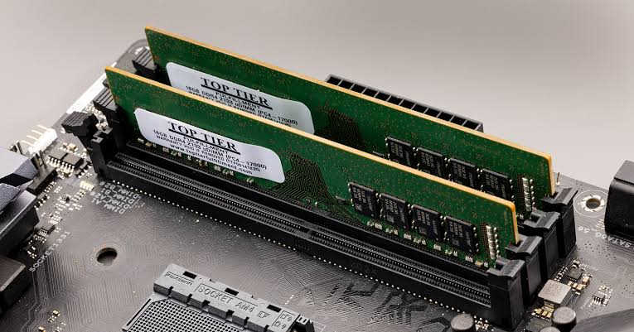
- Take a clear photo showing the installed RAM module. 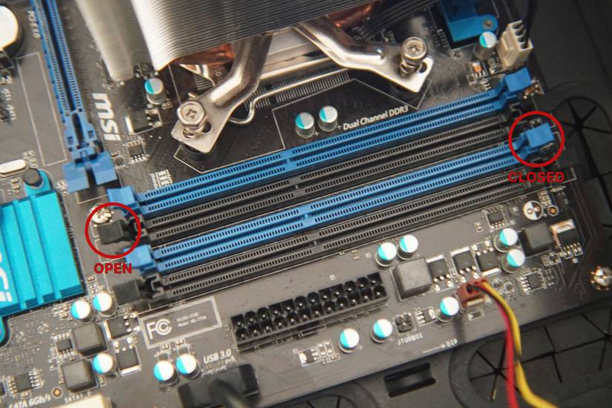
- To remove the RAM:
  - Gently push the retaining clips outward.
  - The module should pop up at an angle.
  - Pull it straight out by holding the edges.
- Reinstall the RAM:
  - Align the notch on the module with the key in the slot.
  - Insert it at the correct angle.
  - Press down firmly until both retaining clips click into place. 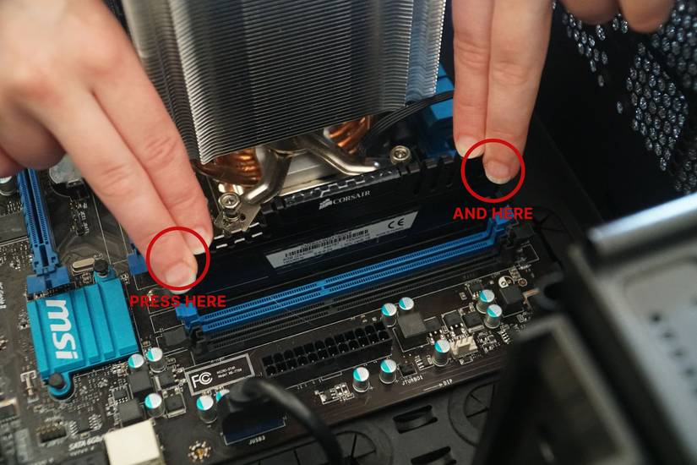
- Reassemble the computer, reconnect the power, and turn it on.
- Verify that the system boots successfully. If it does, the RAM is properly seated.
If your computer does not boot after reinstalling the RAM:
- Power it off and disconnect power again.
- Remove and reseat the RAM, ensuring it is fully inserted.
- If there are multiple RAM modules, test them one at a time if necessary.
- Consult your device's service manual for model-specific instructions.
If you tell me your laptop or desktop model, I can provide model-specific guidance or help you identify the correct RAM slot and installation method.
- list three key differences between HDD, SSD, and NVMe storage types, and for each, name one app or use case (from apps you use daily) that would benefit most from that storage type.

Here are three key differences between HDD, SSD, and NVMe storage, along with a daily-use app or use case that benefits most from each.
Feature | HDD (Hard Disk Drive) | SSD (Solid State Drive) | NVMe SSD (Non-Volatile Memory Express)
Speed | Slowest (uses spinning disks) | Much faster than HDD | Fastest (uses PCIe interface)
Technology | Mechanical moving parts | Flash memory, no moving parts | Flash memory with a high-speed NVMe protocol
Best Use | Large, low-cost storage | Everyday computing and faster boot times | High-performance tasks requiring very fast data access

- Remove the storage drive (HDD or SSD) from your system, take a photo of the connector type (SATA, M.2, or NVMe), and reinstall the drive. Confirm that your device recognizes the storage after reassembly.<br><br><em><strong>Constraint:</strong> Only perform this task if you have access to a device you are allowed to open. If not, find and share a YouTube video link showing the process for your laptop/PC model.</em>

The video demonstrates:
- Powering off the laptop and removing the bottom cover.
- Locating the M.2 NVMe SSD connector.
- Removing the retaining screw and sliding the SSD out of the M.2 slot.
- Reinstalling the SSD and securing it.
- Reassembling the laptop.
If your assignment requires a video for your specific laptop or desktop model, tell me the exact model (for example, HP 15s-fq2717TU, Lenovo IdeaPad Slim 3, Dell OptiPlex 7090, etc.), and I'll find the correct YouTube or manufacturer video for that model.

